High Level Diagram

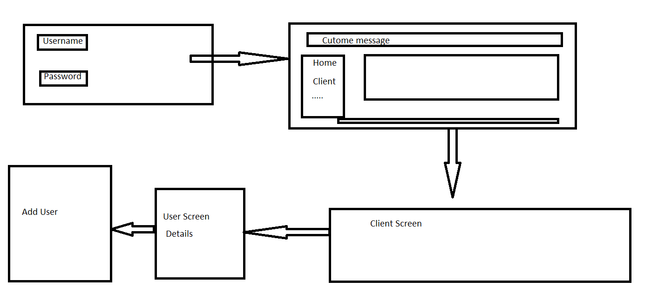

Flow Diagram:

Screenshots:

